**Institute of Engineering & Management**

**Department of Computer Science & Engineering**

**Design & Analysis of Algorithm Lab for 3rd year 5th semester 2018**

**Code: CS 591**

**Date:** 3/10/18

**WEEK-5**

**Assignment-1**

**Problem Statement:** Given a directed acyclic graph, write an algorithm for finding the depth.

**Algorithm:**

**Source code:**

#include <iostream>

#include <vector>

#include <list>

#include <queue>

int main()

{

std::cout<<"Enter the no. of vertices & edges: ";

int v, e; std::cin>>v>>e;

std::vector<std::list<int>> adjList(v);

std::cout<<"Enter the edges with adjacent vertices:\n";

for(int i = 0; i < e; i++)

{

int x, y; std::cin>>x>>y;

adjList[x].push_back(y);

}

std::vector<bool> visited(v,false);

std::vector<int> depth(v,0);

std::cout<<"Enter the source: ";

int start; std::cin>>start;

std::queue<int> q;

q.push(start);

while(!q.empty())

{

int x = q.front();

q.pop();

visited[x] = true;

for(auto &i: adjList[x])

{

if(!visited[i])

{

q.push(i);

visited[i] = true;

depth[i] = depth[x] + 1;

}

}

}

std::cout<<"Depth for each vertex:\n";

for(auto i=0;i<v;i++)

{

std::cout<<i<<" -> "<<depth[i]<<"\n";

}

}

**Screen-Shot:**

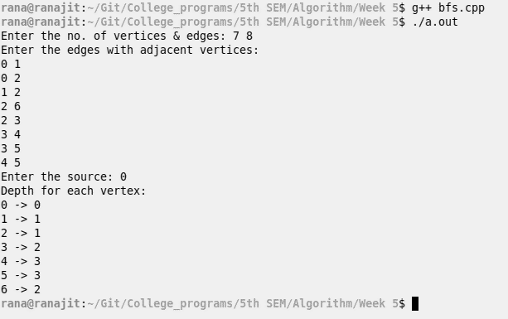

**Time Complexity:**

**Source code:**

#include <iostream>

#include <queue>

#include <vector>

#include <list>

#include <utility>

#include <algorithm>

struct compare

{

bool operator()(const std::pair<int,int> x, const std::pair<int,int y)

{

return x.second >= y.second;

}

};

int main()

{

std::cout<<"Enter the no. of vertices & edges: ";

int e, v; std::cin>>v>>e;

std::vector<std::list<std::pair<int, int>>> adjList(v);

int inf = 1;

std::cout<<"Enter the edges with adjacent vertices and their weights:\n";

for(int i = 0; i < e; i++)

{

int x, y, z; std::cin>>x>>y>>z;

adjList[x].push_back(std::make_pair(y, z));

inf += z;

}

std::vector<int> distance(v, inf);

std::priority_queue<std::pair<int, int>, std::vector<std::pair<int, int>>, compare> pq;

std::cout<<"Enter the source: ";

int src; std::cin>>src;

distance[src] = 0;

pq.push(std::make_pair(src, 0));

while(!pq.empty())

{

int temp = pq.top().first;

pq.pop();

for(auto& i : adjList[temp])

{

int v = i.first;

if(distance[v] > distance[temp] + i.second)

{

distance[v] = distance[temp] + i.second;

pq.push(std::make_pair(v, distance[v]));

}

}

}

std::cout<<"Shortest distances:\n";

for(int i = 0; i < v; i++)

std::cout<<src<<"->"<<i<<" = "<<distance[i]<<'\n';

}

**Screen-Shot:**

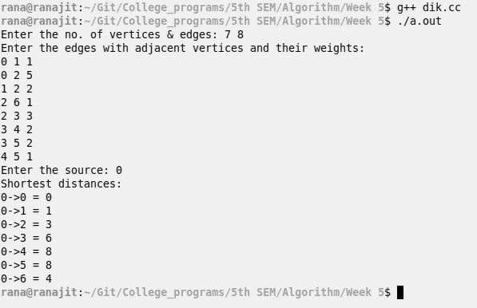

**Time Complexity:**

**Source code:**

#include <iostream>

#include <queue>

#include <vector>

#include <list>

#include <utility>

#include <algorithm>

int main()

{

std::cout<<"Enter the no. of vertices & edges: ";

int e, v; std::cin>>v>>e;

std::vector<std::list<std::pair<int, int>>> adjList(v);

int inf = 1;

std::cout<<"Enter the edges with adjacent vertices and their weights:\n";

for(int i = 0; i < e; i++)

{

int x, y, z; std::cin>>x>>y>>z;

adjList[x].push_back(std::make_pair(y, z));

inf += z;

}

std::vector<int> distance(v, inf);

std::cout<<"Enter the source: ";

int src; std::cin>>src;

distance[src] = 0;

for(int i = 0;i < v-1; i++)

{

std::vector<int> temp(distance);

for(auto j=0;j<v;j++)

{

for(auto k = adjList[j].begin();k!=adjList[j].end();k++)

{

if(distance[k->first] > distance[j]+k->second)

{

temp[k->first] = distance[j] + k->second;

}

}

}

distance = temp;

}

std::cout<<"Shortest distances:\n";

for(int i = 0; i < v; i++)

std::cout<<src<<"->"<<i<<" = "<<distance[i]<<'\n';

}

**Screen-Shot:**

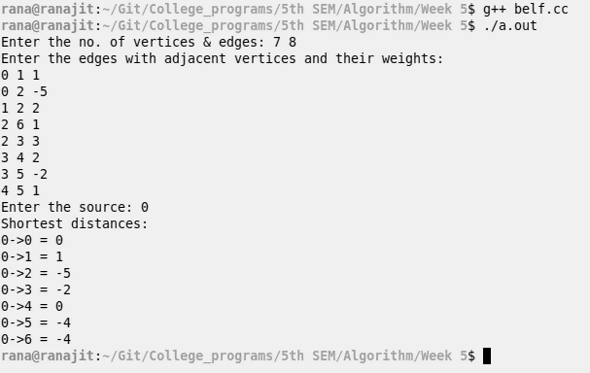

**Time Complexity:**

**Source code:**

#include <iostream>

#include <cmath>

int main()

{

int s, d, smd=0;

std::cout<<"Enter the sum and no. of digits: ";

std::cin>>s>>d;

if((double) s/d > 9)

{

std::cout<<"No number possible!!\n";

return 1;

}

for(int i = 0; i < d; i++)

{

if(i == d-1)

{

smd = s*(int)pow(10, (double)i) + smd;

}

else if(s>9)

{

smd = 9*(int)pow(10, (double)i) + smd;

s -= 9;

}

else{

smd = (s-1)*(int)pow(10, (double)i) + smd;

s = 1;

}

}

std::cout<<"The minimum number possible: "<<smd<<"\n";

}

**Screen-Shot:**

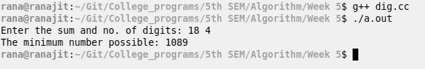

**Time Complexity:**